Need Information from Nitya
Nitya we need to explain a Manufacturing Plant/Factory Floor Operation s detail to Swati.

Terminology used in Factory Floors
Assemble Line
Machines
Types of Machines
Operations on Machines
Station/Workcenter
KPIs that are captured
Reports normally used
Dashboards normally used
Metrics captured (OEE, Scrap/Rejections, Scrap Reasons, Down time Reasons)
Maintenance Terms
Any maintenance activity that needs to be captured (perhaps in future)
Product Terms
Parts
Jobs

If you have a Manufacturing Plant 101 somewhere it can help

- Definitions and examples of Products, Parts, Operations, Machines, Jobs,Process
- Hierarchy of Products, Parts, Operations, Machines, Jobs,Process
- Examples of each of the above categories
- Review Sample Reports
- Report Metrics

Manufacturing usually follows a set of core processes that turn raw materials into finished products. The exact mix depends on the industry (food, electronics, automotive, textiles, etc.), but these are the typical manufacturing processes you’ll see across most factories:

1. Design & Engineering
- Product design (CAD models, drawings)
- Material selection
- Process planning (how it will be made)
- Prototyping and testing

2. Material Preparation
- Sourcing raw materials or components
- Cutting, cleaning, mixing, or pre-treating materials
- Inspection of incoming materials

3. Forming / Shaping
This is where materials get their basic shape:
- Casting (pouring molten material into molds)
- Molding (injection, blow, compression)
- Machining (turning, milling, drilling)
- Forming (forging, stamping, rolling, bending)
- Additive manufacturing (3D printing)

4. Joining / Assembly
- Welding, brazing, soldering
- Fastening (bolts, screws, rivets)
- Adhesive bonding
- Manual or automated assembly lines

5. Surface Treatment & Finishing
- Painting, coating, plating
- Polishing, grinding, deburring
- Heat treatment (hardening, annealing)
- Surface cleaning

6. Quality Control & Inspection
- Dimensional checks
- Functional testing
- Visual inspections
- Statistical process control (SPC)

7. Packaging
- Labeling
- Protective packaging
- Palletizing and unitizing for shipping

8. Storage & Logistics
- Warehousing
- Inventory management
- Shipping and distribution

9. Maintenance & Continuous Improvement
- Equipment maintenance
- Process optimization (Lean, Six Sigma)
- Waste reduction and efficiency improvements

Common Supporting Processes
- Procurement
- Production planning & scheduling
- Health, safety, and environmental (HSE) management
- Documentation and compliance

This is an example of a Turbo Charger assembly line.

Turbocharger Assembly Line (Illustrated)
Machined Components
(compressor housing, turbine housing,
shaft, wheels, bearings, seals)
│
▼
┌────────────────────────────┐
│ Incoming Inspection │
│ - Dimensional checks │
│ - Surface finish │
│ - Material certs │
└────────────────────────────┘
│
▼
┌────────────────────────────┐
│ Parts Cleaning & Prep │
│ - Ultrasonic washing │
│ - Deburring │
│ - Clean-room staging │
└────────────────────────────┘
│
▼
┌────────────────────────────┐
│ CHRA Subassembly Line │
│ (Center Housing Rotating) │
│ │
│ Station 1: Shaft + Bearing │
│ Station 2: Oil seals │
│ Station 3: Thrust system │
│ Station 4: Torque & check │
└────────────────────────────┘
│
▼
┌────────────────────────────┐
│ Rotor Balancing │
│ - Low-speed balance │
│ - High-speed VSR balance │
└────────────────────────────┘
│
▼
┌────────────────────────────┐
│ Compressor Assembly │
│ - Wheel install │
│ - Nut torque │
│ - Clearance verification │
└────────────────────────────┘
│
▼
┌────────────────────────────┐
│ Turbine Assembly │
│ - Turbine wheel fitment │
│ - Heat-shield install │
│ - Axial play check │
└────────────────────────────┘
│
▼
┌────────────────────────────┐
│ Housing Assembly │
│ - Turbine housing clamp │
│ - Compressor housing fit │
│ - Orientation clocking │
└────────────────────────────┘
│
▼
┌────────────────────────────┐
│ Functional Testing │
│ - Oil flow test │
│ - Spin / coast-down test │
│ - Noise & vibration check │
└────────────────────────────┘
│
▼
┌────────────────────────────┐
│ Final Inspection │
│ - End play / radial play │
│ - Visual & torque audit │
│ - Traceability marking │
└────────────────────────────┘
│
▼
┌────────────────────────────┐
│ Packaging & Preservation │
│ - Corrosion protection │
│ - Protective caps │
│ - Serialized labeling │
└────────────────────────────┘
│
▼
Finished Turbocharger


Key Turbo-Specific Realities
- CHRA is the heart of the process—most defects originate here
- Cleanliness is critical (often ISO clean-room standards)
- Balancing happens mid-line, not at the end
- Most lines are semi-automated (robots for balancing & testing, humans for assembly)

Optional Line Enhancements
- Parallel CHRA build cells feeding one final line
- Inline vision systems for seal orientation
- Digital torque tools with auto-logging
- SPC on balance residuals & end play
- Poka-Yoke fixtures to prevent reverse assembly

The above line with Cycle time information. (Example from Chat GPT)

Below is a U-shaped turbocharger assembly cell with realistic example cycle times (these are typical for a semi-automated passenger-vehicle turbo; heavy-duty units run longer).

U-Shaped Turbocharger Assembly Line

Layout (operator inside the “U”)
INBOUND PARTS
│
▼
┌──────────────────────────┐
│ 1. Incoming Inspection │ ←────┐
│ CT: 45 sec │ │
└──────────────────────────┘ │
│ │
▼ │
┌──────────────────────────┐ │
│ 2. Parts Cleaning & Prep │ │
│ CT: 60 sec │ │
└──────────────────────────┘ │
│ │
▼ │
┌──────────────────────────┐ │
│ 3. CHRA Assembly A │ │
│ (shaft + bearings) │ │
│ CT: 75 sec │ │
└──────────────────────────┘ │
│ │
▼ │
┌──────────────────────────┐ │
│ 4. CHRA Assembly B │ │
│ (seals + thrust) │ │
│ CT: 75 sec │ │
└──────────────────────────┘ │
│ │
▼ │
┌──────────────────────────┐ │
│ 5. Rotor Balancing │ │
│ (VSR) │ │
│ CT: 90 sec (auto) │ │
└──────────────────────────┘ │
│ │
▼ │
┌──────────────────────────┐ │
│ 6. Compressor Assembly │ │
│ CT: 60 sec │ │
└──────────────────────────┘ │
│ │
▼ │
┌──────────────────────────┐ │
│ 7. Turbine Assembly │ │
│ CT: 60 sec │ │
└──────────────────────────┘ │
│ │
▼ │
┌──────────────────────────┐ │
│ 8. Housing Assembly │ │
│ CT: 75 sec │ │
└──────────────────────────┘ │
│ │
▼ │
┌──────────────────────────┐ │
│ 9. Functional Test │ │
│ CT: 90 sec (auto) │ │
└──────────────────────────┘ │
│ │
▼ │
┌──────────────────────────┐ │
│10. Final Inspection │ │
│ CT: 45 sec │ │
└──────────────────────────┘ │
│ │
▼ │
┌──────────────────────────┐ │
│11. Pack & Label │ ──────┘
│ CT: 45 sec │
└──────────────────────────┘

OUTBOUND PRODUCT


Cycle Time Summary
Station | Process | Cycle Time
1 | Incoming inspection | 45 s
2 | Cleaning & prep | 60 s
3 | CHRA assembly A | 75 s
4 | CHRA assembly B | 75 s
5 | Rotor balancing (VSR) | 90 s
6 | Compressor assembly | 60 s
7 | Turbine assembly | 60 s
8 | Housing assembly | 75 s
9 | Functional testing | 90 s
10 | Final inspection | 45 s
11 | Pack & label | 45 s

Line Performance (Example)
- Bottleneck: Balancing & functional test (90 s)
- Line takt: ~90 seconds
- Output: ~40 units/hour (single cell)
- Operators: 3–4
  - Operator A: Stations 1–3
  - Operator B: Stations 4–6
  - Operator C: Stations 7–8 + inspection
  - Automation: Stations 5 & 9

Why U-Shaped Works Here
- Operators can service multiple stations
- Easy to rebalance workload
- Shorter walking distances
- Faster problem visibility (andon-style)

Alright, let’s zoom in on how people actually move in this U-shaped turbo cell, and then layer in OEE + downtime so it feels like a real factory, not a textbook 😄

U-Shaped Line with Operator Walk Paths

Operator Assignments
We’ll assume 3 operators + 2 automated stations.
- Operator A → Stations 1–3
- Operator B → Stations 4–6
- Operator C → Stations 7–8 + 10–11
- Automated → Stations 5 (VSR balance), 9 (functional test)

Layout + Walk Paths (Top View)
 ┌───────┐ ┌───────┐
│ 1 │──▶│ 2 │
│ Insp │ │ Clean │
└───▲───┘ └───▲───┘
│ │
│ │
┌───┴───┐ ┌───┴───┐
│ 3 │ │ 4 │
│ CHRA │ │ CHRA │
└───▲───┘ └───▲───┘
│ │
│ │
┌───────────┘ └───────────┐
│ │
│ ┌───────┐ ┌───────┐ ┌───────┐ │
│ │ 5 │──▶│ 6 │──▶│ 7 │ │
│ │ VSR │ │ Comp │ │ Turb │ │
│ └───▲───┘ └───▲───┘ └───▲───┘ │
│ │ │ │ │
│ │ │ │ │
│ ┌───┴───┐ ┌───┴───┐ ┌───┴───┐ │
│ │ 8 │ │ 9 │ │ 10 │ │
│ │ House │ │ Test │ │ Insp │ │
│ └───▲───┘ └───▲───┘ └───▲───┘ │
│ │ │ │ │
│ └───────────┴───────────┘ │
│ │ │
│ ┌───┴───┐ │
│ │ 11 │◀──────────┘
│ │ Pack │
│ └───────┘


Operator Walk Loops

Operator A (Stations 1 → 2 → 3 → 1)
- Small triangular loop
- Walk distance: ~4–5 m per cycle
- Work content: ~180 sec
- No interaction with automated equipment

Operator B (Stations 4 → 5 → 6 → 4)
- Stays close to balancing machine
- Loads/unloads VSR while working Station 6
- Walk distance: ~3–4 m
- Critical for line rhythm

Operator C (Stations 7 → 8 → 10 → 11 → 7)
- Longer loop but lower precision work
- Walk distance: ~6–7 m
- Buffers minor test delays

OEE & Downtime Assumptions
Let’s assume 1 shift = 8 hours = 28,800 seconds

Availability (A)
Typical for semi-automated turbo lines:
Source | Loss
Breaks / meetings | 8%
Minor stops | 4%
Changeover | 2%
Availability | 86%
Available production time:
28,800 × 0.86 ≈ 24,770 sec

Performance (P)
- Ideal cycle (takt): 90 sec
- Small delays (walking, VSR reloads, micro-stoppages)
Performance: ~95%

Quality (Q)
Typical first-pass yield:
Issue | Rate
Balance rework | 2.5%
Leak / oil flow fail | 1.5%
Assembly defects | 1.0%
Good units | 95%

Overall OEE
OEE = Availability × Performance × Quality
OEE = 0.86 × 0.95 × 0.95 ≈ 0.78 (78%)


Actual Output per Shift
- Ideal output:
28,800 ÷ 90 = 320 units
- OEE-adjusted output:
320 × 0.78 ≈ 250 units / shift

Where Real Lines Improve This
- Add auto-load/unload to VSR (+3–4% A)
- Combine Stations 10 & 11 (+1 operator freed)
- Add parallel test station to de-risk bottleneck
- Tighten balance SPC → fewer re-runs (+Q)

If you want, next we can:
- Do a Yamazumi chart
- Simulate 2-shift vs 3-shift output
- Rebalance operators to 2-person cell
- Add andon logic & escalation rules
Just say the direction 🛠️📈
Perfect — a Yamazumi chart is exactly the right next step for this cell. I’ll build it cleanly and then interpret it like a line-balancing review.

Yamazumi Chart – Turbocharger U-Shaped Cell
Takt time: 90 seconds
Goal: No operator bar exceeds takt

Work Content by Operator (Manual Time Only)
Automated time (VSR + functional test) is not counted as operator load, only load/unload and interaction time.

Operator A (Stations 1–3)
Task | Time (sec)
Incoming inspection | 45
Parts cleaning & prep | 60
CHRA assembly A | 75
Total | 180

Operator B (Stations 4–6)
Task | Time (sec)
CHRA assembly B | 75
VSR load/unload | 30
Compressor assembly | 60
Total | 165

Operator C (Stations 7–8, 10–11)
Task | Time (sec)
Turbine assembly | 60
Housing assembly | 75
Final inspection | 45
Pack & label | 45
Total | 225

Text Yamazumi Visualization
Each █ ≈ 15 seconds
Takt line = 90 sec
Takt (90s) ──────────────────────────────

Operator A:
[████████████████████████████] 180s
^^^^^^^^^^^^^^^^^^^^^^^^^^^^
Over takt by +90s

Operator B:
[███████████████████████] 165s
^^^^^^^^^^^^^^^^^^^^^^
Over takt by +75s

Operator C:
[████████████████████████████████] 225s
^^^^^^^^^^^^^^^^^^^^^^^^^^^^^^^
Over takt by +135s


What This Tells Us (Key Insights)

🔴 Cell is NOT balanced
- All three operators exceed takt
- Operator C is the worst overload
- This works only because:
  - Operators are offset in the U
  - Automation absorbs variation
  - Small buffers exist between stations

Balanced Yamazumi (Improved State)

Reallocation Proposal
- Move Final Inspection (45s) from C → A
- Move Pack & Label (45s) from C → B
- Add auto-cleaning fixture (–30s at Station 2)

New Operator Loads

Operator A
- Inspection (45)
- Cleaning (30)
- CHRA A (75)
- Final inspection (45)
Total: 195 → 165 sec

Operator B
- CHRA B (75)
- VSR load/unload (30)
- Compressor (60)
- Pack & label (45)
Total: 210 → 165 sec

Operator C
- Turbine (60)
- Housing (75)
Total: 135 sec

Balanced Yamazumi (After Improvements)
Takt (90s) ──────────────────────────────

Operator A:
[███████████████████████] 165s

Operator B:
[███████████████████████] 165s

Operator C:
[█████████████████] 135s


Reality Check
This line still can’t hit 90s takt with 3 operators unless:
- You split into 2 parallel CHRA cells, or
- Add a 4th floating operator, or
- Increase takt to 120 sec
👉 That’s exactly the kind of insight Yamazumi is supposed to surface.

Metrics and Dashboards:

This is basically the dashboard that runs a factory. Most plants track a mix of safety, quality, delivery, cost, and people metrics (often called SQDCP or PQCDSM).

1. Safety Metrics (always #1)
These come first on every real plant dashboard.
- TRIR (Total Recordable Incident Rate)
- Lost Time Injury Frequency (LTIFR)
- Near-miss reports
- Days since last incident
- Safety audit score / compliance rate

2. Quality Metrics
“How good is what we’re making?”

Core
- First Pass Yield (FPY)
- Scrap rate (%)
- Rework rate (%)
- Defects per unit (DPU / PPM)
- Customer returns / warranty rate

Process Control
- SPC capability (Cp, Cpk)
- Top defect Pareto
- Right-first-time (%)

3. Delivery / Flow Metrics
“Are we delivering what we promised, when we promised?”
- On-Time Delivery (OTD)
- Schedule adherence
- Lead time
- Throughput (units/hour)
- Backlog / past-due orders
- Takt attainment

4. Cost Metrics
“How much does it really cost to make this?”
- Cost per unit
- Labor efficiency
- Overtime %
- Scrap & rework cost
- Inventory carrying cost
- Conversion cost

5. Productivity & Equipment Metrics
“How well are we using our assets?”

Equipment
- OEE (Availability × Performance × Quality)
- Downtime (planned vs unplanned)
- MTBF / MTTR
- Changeover time (SMED)

Labor
- Units per labor hour (UPH)
- Labor utilization
- Absenteeism rate
- Training coverage / skill matrix

6. Inventory & Material Metrics
“Is material flowing or sitting?”
- Inventory turns
- WIP level
- Days of inventory on hand
- Material shortages
- Supplier PPM
- Incoming quality acceptance rate

7. Continuous Improvement Metrics
“Are we getting better?”
- Kaizen count / savings
- Problem-solving closure rate
- Corrective action aging
- Standard work adherence
- 5S audit score

8. People & Culture Metrics
(Plants that ignore these pay later.)
- Training hours per employee
- Skill coverage (% multi-skilled)
- Employee turnover
- Suggestion rate
- Engagement survey score

Typical Metric Stack by Level

Shop Floor (Hourly / Daily)
- Safety incidents
- FPY
- Hourly output vs plan
- Downtime minutes
- Andon calls

Plant Management (Weekly)
- OEE
- Scrap cost
- OTD
- Labor efficiency
- Top losses

Executive (Monthly)
- Cost per unit
- Inventory turns
- Warranty claims
- Capacity utilization
- EBITDA impact

What Good Plants Do Differently
- Track fewer metrics, but review them daily
- Tie metrics to clear owners
- Use visual boards, not spreadsheets
- Focus on leading indicators (FPY, downtime), not just lagging ones

Example of a printable one-page plant KPI dashboard in the canvas that you can use for daily stand-ups, tier meetings, or visual boards.

Manufacturing Plant KPI Dashboard (One Page)

📍 Plant Overview
- Plant: ____________________
- Date / Shift: ____________________
- Product Family: ____________________
- Takt Time: __________ sec
- Planned Output: __________ units

🛡️ Safety (Always First)
Metric | Target | Actual | Status
Recordable Incidents | 0 |  | 🟢 / 🟡 / 🔴
Near Misses Reported | ≥5 / week |  | 🟢 / 🟡 / 🔴
Days Since Last Incident | ↑ |  | 🟢 / 🟡 / 🔴

✅ Quality
Metric | Target | Actual | Status
First Pass Yield (FPY) | ≥95% |  | 🟢 / 🟡 / 🔴
Scrap Rate | ≤2% |  | 🟢 / 🟡 / 🔴
Rework Rate | ≤1% |  | 🟢 / 🟡 / 🔴
Customer Complaints | 0 |  | 🟢 / 🟡 / 🔴
Top Defect Today: _______________________________

🚚 Delivery / Flow
Metric | Target | Actual | Status
Output vs Plan | 100% |  | 🟢 / 🟡 / 🔴
On-Time Delivery (OTD) | ≥98% |  | 🟢 / 🟡 / 🔴
Schedule Adherence | ≥95% |  | 🟢 / 🟡 / 🔴
Average Lead Time | ↓ |  | 🟢 / 🟡 / 🔴

⚙️ Productivity & Equipment
Metric | Target | Actual | Status
OEE | ≥80% |  | 🟢 / 🟡 / 🔴
Availability | ≥90% |  | 🟢 / 🟡 / 🔴
Performance | ≥95% |  | 🟢 / 🟡 / 🔴
Quality (OEE) | ≥98% |  | 🟢 / 🟡 / 🔴
Top Downtime Cause: _______________________________

💰 Cost
Metric | Target | Actual | Status
Cost per Unit | ↓ |  | 🟢 / 🟡 / 🔴
Scrap Cost | ≤$____ |  | 🟢 / 🟡 / 🔴
Overtime % | ≤5% |  | 🟢 / 🟡 / 🔴

📦 Inventory & Material
Metric | Target | Actual | Status
WIP Level | ≤___ units |  | 🟢 / 🟡 / 🔴
Inventory Turns | ≥__ |  | 🟢 / 🟡 / 🔴
Material Shortages | 0 |  | 🟢 / 🟡 / 🔴

👥 People & Improvement
Metric | Target | Actual | Status
Absenteeism | ≤3% |  | 🟢 / 🟡 / 🔴
Training Coverage | ≥90% |  | 🟢 / 🟡 / 🔴
Kaizens Open / Closed | ≤30 days |  | 🟢 / 🟡 / 🔴

🔧 Top Issues & Actions (Today)
Issue | Owner | Action | Due Date

📌 Escalation Rules
- 🔴 Any Safety incident: Immediate escalation
- 🔴 Output <90% of plan: Line leader + maintenance
- 🔴 FPY < target: Quality + production review

This dashboard is designed for daily stand-up and visual management. Update once per shift.

How this is meant to be used (quick guidance)
- Update once per shift, not continuously
- Use 🟢 / 🟡 / 🔴 status — avoid raw numbers-only reviews
- Focus discussion on:
  - 🔴 items only
  - Top defect
  - Top downtime cause
  - Actions with owners & dates

What makes this dashboard effective
- Follows SQDCP flow (Safety → Quality → Delivery → Cost → People)
- Separates leading indicators (FPY, downtime) from lagging ones (cost)
- Forces ownership and escalation, not just reporting

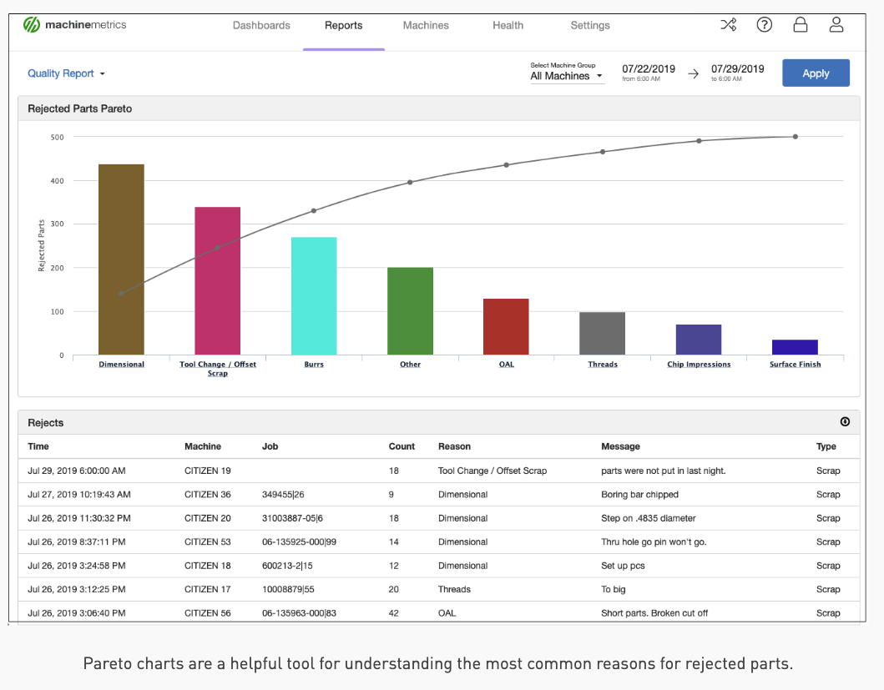
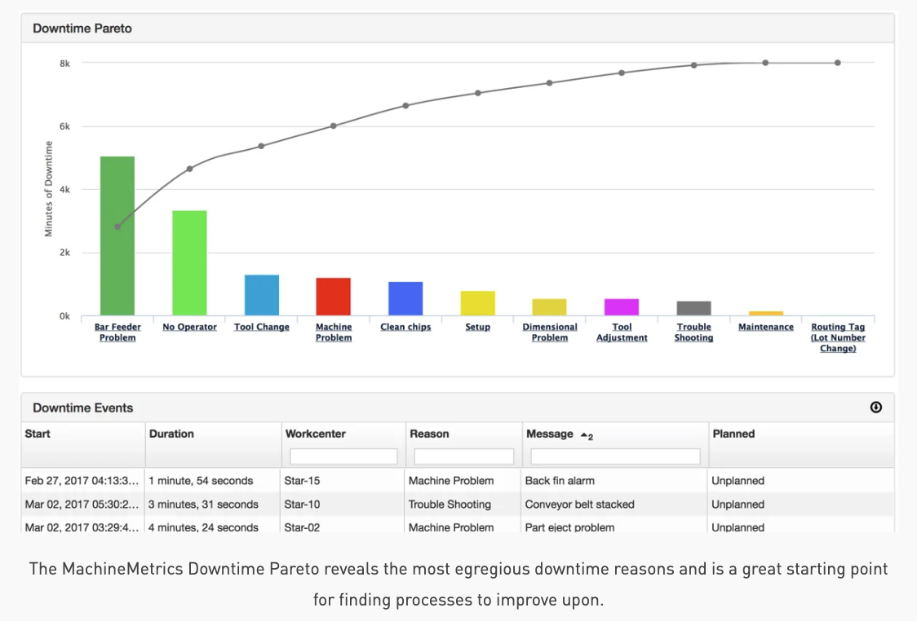

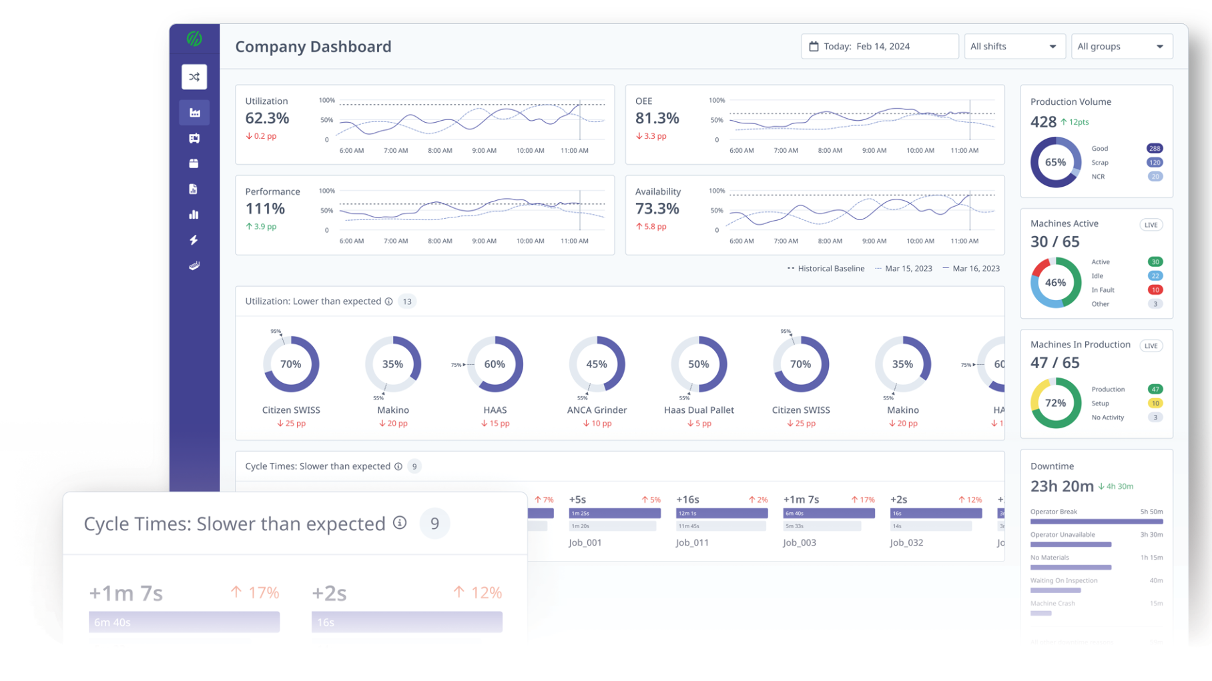

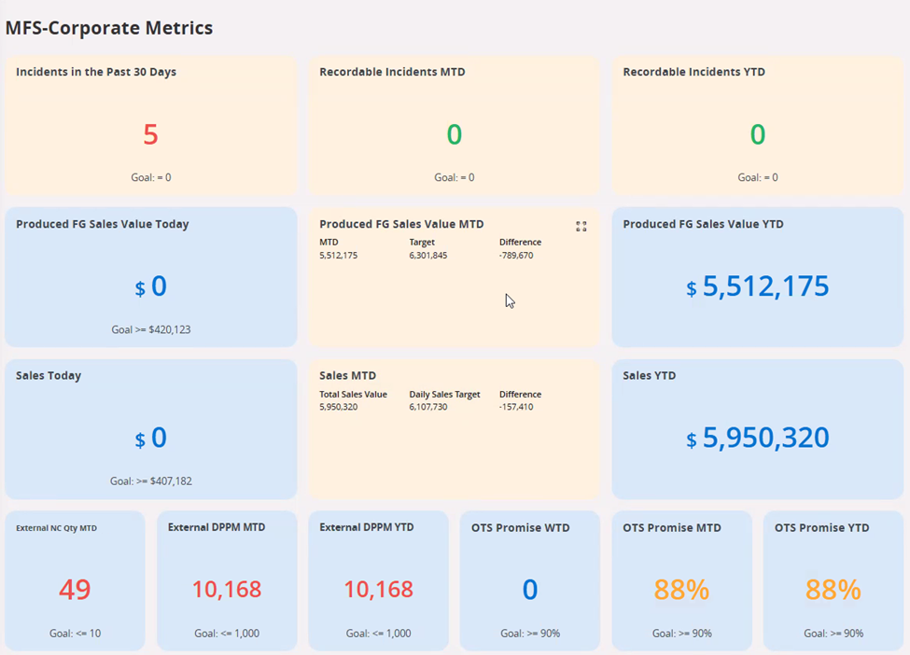

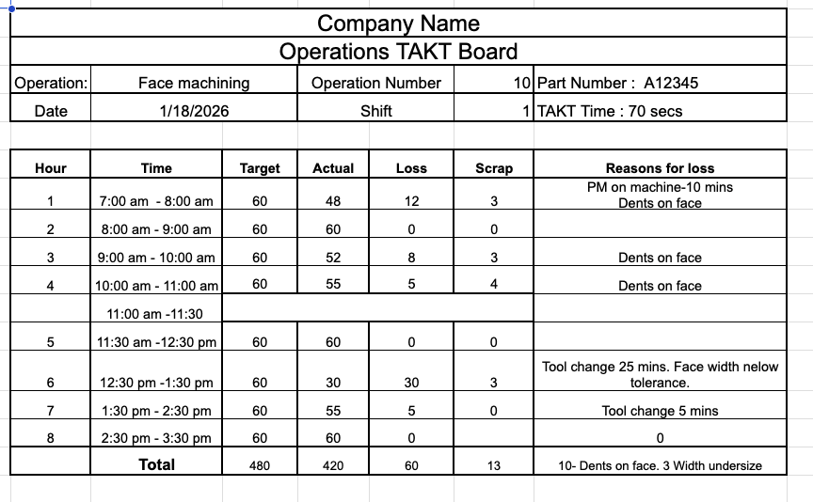

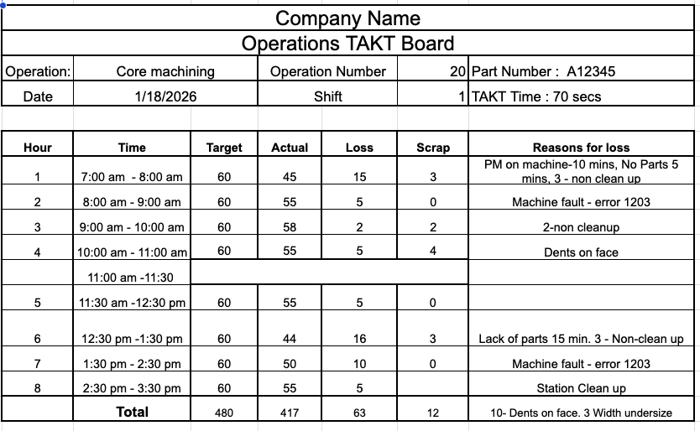
We want to create a Quality Report.The report focuses on identifying and categorizing manufacturing defects to help teams understand where they are losing the most production value.
The report is broken down into two primary sections: a high-level visual Pareto chart and a detailed data log.

1. Rejected Parts Pareto (The Chart)
- Bar Chart (X-Axis): Shows the scrap reasons for the rejected part. If the Scrap reason is too long then do wrap text.
- Bar Chart (Y-Axis): Shows the raw count of rejected parts for each scrap reason. Add the number as a label to the bar.
- Trend Line: Overlay a trend line on the bar chart with cumulative percentage line

2. Rejects Log (The Table)
Show a table that provides granular data, context for specific scrap events. Create these columns for key data points
- Machine Name
- Operation
- Scrap Count
- Scrap Reason
- Add another column on the right for Operator Notes

Operator - Is the person who operates the machine/machines
Will need access to the machine
Can view reports/activity of the machine
Will input operations logs for the operation on the machine, production loss, downtime, scrap/reject

Lead - Is the Operations Lead for the Assembly Line
Will need access to all the machines in the assembly line
Can view reports/activity of all the machines in the assembly line
Will input or approve operations logs for the operation on all the machines, production loss, downtime, scrap/reject in the assembly line

Supervisor - Is the Supervisor for the Operations (What are other differences between Lead and Supervisor)
Will need access to all the machines in all the assembly lines under his supervision
Can view reports/activity of all the machines in all the assembly lines under his supervision
Will input or approve operations logs for the operation on all the machines, production loss, downtime, scrap/reject in the assembly line
Will manage the staffing on the assembly line

Manager - Manages the operations of a particular part or component
Will need access to all the machines in all the assembly lines under his supervision
Can view reports/activity of all the machines for the part or component under his/her management
Responsible for the OEE of the operations under his/her management

GM/Plant Manager - Manages the operations of the plant
Responsible for the budget, operations, quality, staffing, efficiency of the entire plant
Has access to higher level dashboards for the entire operations

